After Service Prayer

Immediately following the morning service, members of the Prayer Team are available to meet and pray with you at the front of the church beneath the Cross.

Parking

Our upper parking lot is needed by those with mobility issues to enter the auditorium on ground level. If you and your family can use the stairs, please park in the lower/front lot.

Note: We have been asked by our neighbours at Parklane Apartments not to park in their visitors parking during our services, as this parking is for their visitors.

Additional parking is available at the old Shoppers Drug Mart location, or on Victoria St across from the laundromat.

Note: The office hours will be irregular during Christmas week. Please call before coming into the office.

To hear today’s message again or to see the bulletin, please visit our website: www.mylakeside.ca
Advent

ad·vent /’ad,vent/
From the Latin, meaning “come into,”
Just as Jesus came into the world for us

During the season of Advent, we celebrate Christ’s coming into the world and watch with expectant hope for His coming again. This morning we celebrate the Third Sunday of Advent and light the Candle of Love.

“For God so loved the world that He gave His one and only son that whosoever believes in Him should not perish but have everlasting life.” John 3:16

Notes

John Troke has applied for membership at Lakeside Church and based on his successful elder interview has been affirmed by the Elders Board. If anyone has any objections or knows of any reason why he should not be accepted into full

Membership, they are to bring their concerns to the Elders Board. Pending any impediment, he will be welcomed into membership within five weeks.

Please pick up your 2019 Offering Envelopes from the table in the lobby. If you would like envelopes please contact Alison in the Church Office. Pre-authorized giving is also available. If you would like to participate in this, please pick up the form at the Kiosk and return it to Alison Bangay in the office or put in her Care Card folder.

Life Groups (Small Groups) will begin once again at the beginning of February.More locations and dates will be available. Please consider joining a Life Group. This is where ‘doing life together’ really happens. More details in the coming weeks.

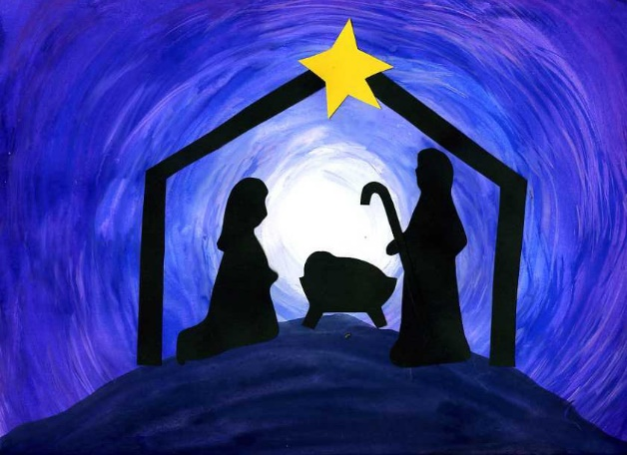

December 23, 2018

Today’s Speaker –
Pastor Paul Graham

9 Park Street, PO Box 749
Haliburton, ON K0M 1SO
(705) 457 2851
www.mylakeside.ca
info@mylakeside.ca
www.facebook.com/mylakesidechurch

Weekly Programs
Sunday
Young Adults Ministry -7:00 pm. A weekly ministry for all those finished high school to age 30ish, (unmarried or married without children). Call/text Steve 705-457-0124 or Beth 705-457-5806.
Will begin again in January.

Tuesday
North of 50 - 10:00 am to noon. An opportunity for ‘seniors’ to enjoy conversation, table games, and refreshments. Everyone is welcome. Will begin again in January.

Wednesday
Women of the Word (WOW) – 9:15-11:45 Lakeside women and friends come and join us to have a time of bible study and a time to visit with your sisters in Christ. Childcare provided up to age 4. Will begin again in January.

Family Night –5:30–7:30 pm. Starting with dinner and followed by a study for children JK to Grade 4 and a Bible study for parents. Youth grades 5 and up are welcome to help where needed. Nursery provided for pre-school children. For information, contact Elena at elenabjelis@gmail.com. Will begin in January.

Prayer Times

Sunday:
9:00 am - everyone is welcome to a time of pre-service prayer

Wednesday:
8:00 am - MEN’S PRAYER TIME

Sunday School

Sunday school for children ages 0-24 months (nursery is off foyer),
Toddlers for infants 2-3 (lower level. All others will remain in the service.

Upcoming Lakeside Events

Christmas Eve Candle Light Service – Monday, December 24th at 6:00 pm.

Team Challenge - Sunday, January 6th at the 10:00 am morning service - Come and hear a dynamic presentation by Teen Challenge featuring students sharing their amazing stories of freedom from addiction.

Spaghetti Dinner Fundraiser – Sunday, January 13th
Three Sittings – 5:00 pm, 6:00 pm, 7:00 pm – The dinner is to raise money toward the trip to Columbia in March of 2019. This is a free dinner but donations would be gratefully accepted and there will be an auction of desserts. Please RSVP to Chris Weir – chris@mylakeside.ca or (905) 379-8861.

Work as Worship Conference - rightnow MEDIA -
It will be held on March 8th from 9:00 am to 4:00 pm. An opportunity to learn more about combining your workplace with ministry. For more information, please contact the church office at (705) 457-2851.

Mission Prayer

Russ & Meredith Martin – Power to Change – www.p2c.com Singapore/Asia

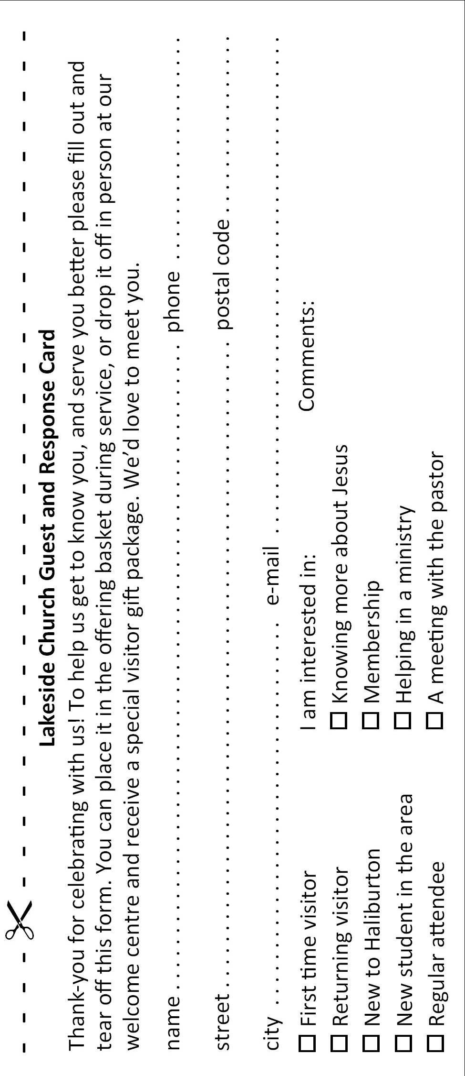
Pray for Russ and Meredith to work effectively as a team as they transition their family to living in Singapore. Pray for their mystruggles.in outreach site pilot in New Delhi India. Pray that this new site would be effective at reaching urban Indians and connecting them with people that can help mentor them in the local churches.

