After Service Prayer

Immediately following the morning service, members of the Prayer Team are available to meet and pray with you at the front of the church beneath the Cross.

Parking

Our upper parking lot is needed by those with mobility issues to enter the auditorium on ground level. If you and your family can use the stairs, please park in the lower/front lot.

Note: We have been asked by our neighbours at Parklane Apartments not to park in their visitors parking during our services, as this parking is for their visitors.

Additional parking is available at the old Shoppers Drug Mart location, or on Victoria St across from the laundromat.

To hear today’s message again or to see the bulletin, please visit our website: www.mylakeside.ca

Advent

ad·vent /’ad,vent/
From the Latin, meaning “come into,”
Just as Jesus came into the world for us

During the season of Advent, we celebrate Christ’s coming into the world and watch with expectant hope for His coming again. This morning we celebrate the Third Sunday of Advent and light the Candle of Joy.

They were terrified, ¹⁰ but the angel reassured them. “Don’t be afraid!” he said. “I bring you good news that will bring great joy to all people. ¹¹ The Savior—yes, the Messiah, the Lord—has been born today in Bethlehem, the city of David! Luke 2:9b-11

Notes

The following people have applied for membership at Lakeside Church and based on their successful elder interview have been affirmed by the Elders Board. If anyone has any objections or knows of any reason why they should not be accepted into full

Membership, they are to bring their concerns to the Elders Board. Pending any impediment, they will be welcomed into membership within five weeks – Curtis & Micheon Hutchings, Travis & Alicia Braun and John Troke.

Please pick up your 2019 Offering Envelopes from the table in the lobby. If you would like envelopes please contact Alison in the Church Office. Pre-authorized giving is also available. If you would like to participate in this, please pick up the form at the Kiosk and return it to Alison Bangay in the office or put in her Care Card folder.

December 16, 2018

Today’s Speaker –
Pastor Paul Graham

9 Park Street, PO Box 749
Haliburton, ON K0M 1SO
(705) 457 2851
www.mylakeside.ca
info@mylakeside.ca
www.facebook.com/mylakesidechurch

Weekly Programs
Sunday
Young Adults Ministry -7:00 pm. A weekly ministry for all those finished high school to age 30ish, (unmarried or married without children). Call/text Steve 705-457-0124 or Beth 705-457-5806.

Tuesday
North of 50 - 10:00 am to noon. An opportunity for ‘seniors’ to enjoy conversation, table games, and refreshments. Everyone is welcome.

Wednesday
Women of the Word (WOW) – 9:15-11:45 Lakeside women and friends come and join us to have a time of bible study and a time to visit with your sisters in Christ. Childcare provided up to age 4. Will begin again in January.

Family Night –5:30–7:30 pm. Starting with dinner and followed by a study for children JK to Grade 4 and a Bible study for parents. Youth grades 5 and up are welcome to help where needed. Nursery provided for pre-school children. For information, contact Elena at elenabjelis@gmail.com Will begin in January.

Prayer Times

Sunday:
9:00 am - everyone is welcome to a time of pre-service prayer
7:30 pm – prayer for one another, our church and our community. Everyone is welcome.

Wednesday:
8:00 am - MEN’S PRAYER TIME
Sunday School

Sunday school for children ages 0-24 months (nursery is off foyer),
Toddlers for infants 2-3 (lower level), Children’s Church open session for children grades JK to grade 2, Mid school for children grades 3 – 5, Junior High grades and Senior High will have classes.

Upcoming Lakeside Events

Shepherd’s Table - Friday, December 21st 5:30 pm. Come and invite a friend to enjoy a free nutritious dinner. Please contact Shirley Cowling at jscowling@sympatico.ca if you would like to help.

Christmas Eve Candle Light Service – Monday, December 24th at 6:00 pm.

Mission Prayer

Russ & Meredith Martin – Power to Change – www.p2c.com Singapore/Asia

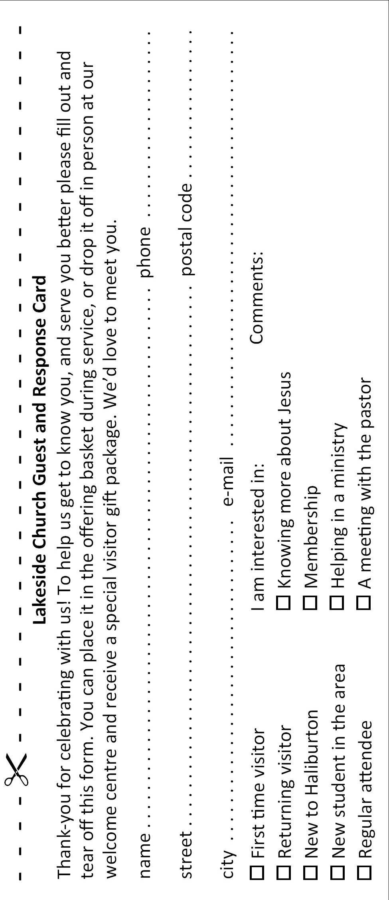
Pray for wisdom in knowing which local church for the Martins to engage with in Singapore. Pray for Jomer, Mel and Ace, the leaders of the boilingwaters.ph team. They have an audience of over 1.2M on social media in the Philippines. Pray that many would come to Christ through their online chat outreach program.

