Notes / Comments

Immediately following the morning service, members of the Prayer Team are available to meet and pray with you at the front of the church beneath the Cross.

PARKING

Our upper parking lot is needed by those with mobility issues to enter the auditorium on ground level. If you and your family can use the stairs, please park in the lower/front lot.

Note: We have been asked by our neighbours at Parklane Apartments not to park in their visitors parking during our services, as this parking is for their visitors. Additional parking is available at the old Shoppers Drug Mart location, or on Victoria St across from the laundromat.

LAKESIDE & MBC UPDATE

Over the next few weeks, please pray for wisdom for the pastors and leaders of MBC and Lakeside.

Fridge Reminders
To hear today’s message again or to see the bulletin, please visit our website: www.mylakeside.ca
YOUTH

BLAST Junior High (grades 6-8) meets Friday evening from 6:30 to 8:30 pm. Come out, enjoy some food and hang with friends. Contact Chris at chris.weir121@gmail.com or text 905-379-8861 for more information.

RIOT Senior High (grade 9-12) meets Friday evening from
7:30 – 10:00 pm. Contact Chris at chris.weir121@gmail.com or text 905-379-8861 for more information.

MISSIONS

Jessica Taylor – Association of Baptists for World Evangelism Canada www.abwe.ca North Africa
Please pray for Jessica as she continues her studies for her Master’s in Education. Pray that she would be able to find a good balance along with her commitments and ongoing ministry with her students and their families.

ELDERS NOTE - MEMBERSHIP

The following people have applied for membership at Lakeside Church and based on their successful elder interview have been affirmed by the Elders Board. If anyone has any objections or knows of any reason why they should not be accepted into full membership, they are to bring their concerns to the Elders Board. Pending any impediment, they will be welcomed into membership within five weeks. – Amanda Pyl, Pat and Jashelle Kitcheman, Katie Stiver and Chris and Melissa Weir.

CHRISTMAS MUSIC

Come and enjoy a fun concert “Deck the Halls with Songs and Laughter” on Sunday , December 2nd at 3:00 pm or Tuesday , December 4th at 7:30 pm at Haliburton United Church, 10 George St. Admission is $15.00. Tickets are available at Cranberry Cottage, Haliburton or Minden Pharmasave, Minden or call 705-457-4916.

November 11, 2018

We welcome you this Sunday morning as we celebrate our great God.

Our Speaker Today is Pastor Paul Graham
Message: Joseph -Week 4

Park Street, PO Box 749
Haliburton, ON K0M 1SO
(705) 457 2851
www.mylakeside.ca
admin@mylakeside.ca
www.facebook.com/mylakesidechurch

SUNDAY SCHOOL

Sunday school for children ages 0-24 months (nursery is off foyer)
and toddlers for infants 2-3 (lower level), Children’s Church open session for children grades JK to grade 2. Mid school for children grades 3 – 5 will remain in the service. Junior High grades and Senior High will have classes.

NEWCOMERS LUNCH

If you are new to the church in the last few months or just feel like you are still new and have questions... you are invited to our Newcomers Lunch after service today at 1145 Grass Lake Road. Come to meet the pastor, make new friends, ask questions and learn more about Lakeside.

PRAYER TIMES

Sunday morning at 9:00 am, everyone is welcome to a time of pre-service prayer in the library area.

Sunday evening at 7:30 pm, join us to lift up each other, our church and community in prayer. We will meet in the Library. Everyone is welcome.

Wednesday morning – Men join us at 8:00 am for a time to pray for our families, each other, the church and community. Prayer is an important cornerstone in our church foundation and you will be surprised how meaningful this time can become for you.

PROGRAMS

North of 50 - Tuesday morning from 10:00 am to noon. Join us for a time of conversation, table games and a chance to connect with others and enlarge your friendship circle. Refreshments provided and everyone is welcome.

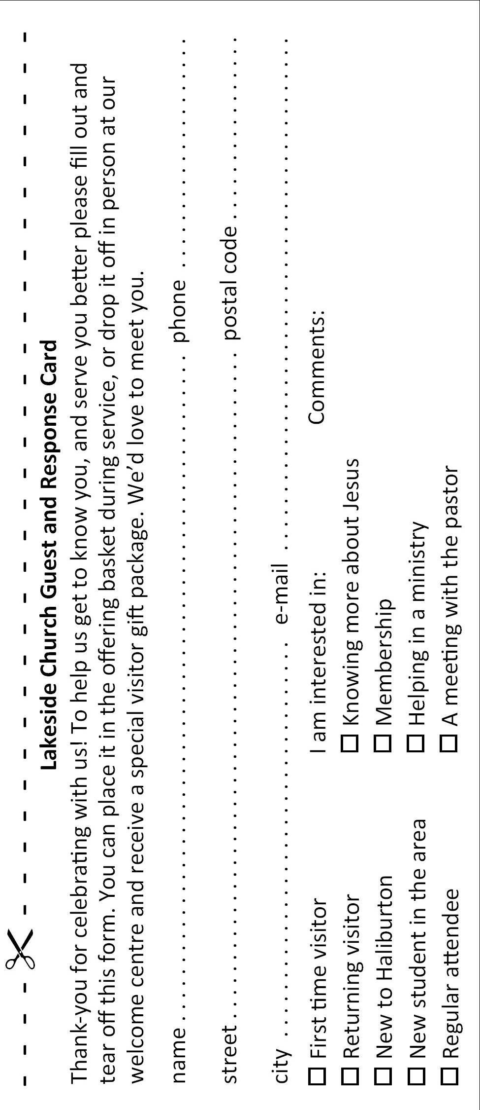
Bible Study for Men and Women Tuesday evenings until November 27th from 6:30-8:30 pm. For more information, contact Wendi Graham at wendigraham@live.ca or 705-457-2451.
PROGRAMS (Cont’d)

Family Night – Wednesday evening at 5:30–7:30 pm, starting
with dinner and followed by a study of the Beatitudes for children JK to Grade 4 and a Bible study for parents. Youth grades 5 and up are welcome to help where needed. Nursery provided for pre-school children. For information, contact Elena at elenabjelis@gmail.com

Women of the Word (WOW) Lakeside women and friends come and join us Wednesday morning at 9:15-11:45 am to have a time of bible study and a time to visit with your sisters in Christ. For more information, contact Alison in the office or email alison@mylakeside.ca. Childcare provided up to age 4.

Women’s Bible Study is on Thursday evenings and running every second Thursday in the library. Two studies will be occuring – Missional Motherhood at 6:30 pm. and Kingdom Woman at 8:00 pm. For more information contact Micheon Hutchings at 705-457-7412 or email micheon_reay@hotmail.com.

Lakeside Young Adults Ministry, Sunday evening at 7:00 pm at the home of Steve and Beth Archibald. This is a weekly ministry for all those finished high school to age 30ish, (unmarried or married without children). For more information, call or text Steve 705-457-0124 or Beth 705-457-5806.

SHEPHERD’S TABLE

Friday, November 16th 5:30 pm. Come and invite a friend to enjoy a free nutritious dinner. Please contact Shirley Cowling at jscowling@sympatico.ca if you can help.

COFFEE FUNDRAISER

For the month of November we are serving coffee from the Pregnancy Care & Family Support Centre. To support their fundraiser you can order coffee online at www.haliburtonpregnancycentre or call 705-457-4673.

