Notes / Comments

Immediately following the morning service, members of the Prayer Team are available to meet and pray with you at the foot of the Cross.

MISCELLANEOUS

In Search of: Reclaimed dock/barn boards
Got your dock in? Need a new one next spring? The church is looking for reclaimed dock or barn boards for some projects. If you have some good quality reclaimed wood stacked in a shed or leaning against the garage you are willing to part with, let us know. We could use it.

Green Thumbs: Still looking for your ONE ministry for SERVICE? We have an opening in our gardening department! If you get the itch to plant and weed when Spring blooms, or prune and rake when Fall comes, please contact the office or Pastor Paul to find out how you can help keep our church looking great year-round!

UPCOMING EVENTS

Calling all choir voices! Miss singing in a choir or always wanted to? Our “Church in Haliburton” November worship will include a multi-church choir led by Bill Gliddon from the Anglican Church. Short practices of the hymns and songs will be held at St. Georges on November 2nd, 9th and 16th at 7:30 pm. The
Worship Night will be November 22^{nd.} You don’t have to contact anyone…just show up for practice and you are in the choir!

Fridge Reminders
To hear today’s message again, please visit our website: www.mylakeside.ca
SAMARITANS PURSE

Operation Christmas Child Shoe Boxes and a suggestion items list for 10-14 year olds are at the kiosk. Please bring your box back to Lakeside before Sunday, November 12th.

YOUTH

Riot - Anyone in grades 9-12 is welcome to join us for fun and games every Friday at 7:30 pm. For more information on weekly events, please call or text Micheon Hutchings at 705-457-7412 or like The Riot on Facebook.

Blast Junior high youth group is for students in grades 6-8. We meet Friday evening from 7:00 to 9:00 pm. This fall we are partnering with Youth Unlimited so contact Dana McMahon at 705-854-1043 or dana@youthunlimitedkaw.com for more details.

Trunk or Treat is replacing our Midweek event this week.

“TREAT ON THE STREET”
Neighbourhood outreach
OCTOBER 31 @ 6 PM
Lakeside Church
JOIN IN THIS FAMILY FUN –
DECORATE YOUR TRUNK
AND SHARE SOME TREATS WITH THE KIDS
WON’T YOU BE MY NEIGHBOUR?
PLEASE CALL ELENA FOR DETAILS –
Church office 705 457-2851

ELDER ASSIGNMENTS

The assignments of the new lead elders and their back-up in each area of ministry for the coming year is below:

Worship and Prayer - Jim Cowling/Gord Forbes
Discipleship and Care - Gord Forbes/Jim Cowling
Children and Youth - Graham Borgdorff/Mark Bangay
Outreach and Partners - Mark Bangay/Olaf Kraulis
Stewardship - Olaf Kraulis/Graham Borgdorff
Elders Chair - Bruce Dunning/Vice Chair - Mark Bangay

In addition to Pastor Paul and the staff (for day to day things), the elders are available to assist you in the leadership of your ministry, help with any difficulties, provide information and council, and to encourage and pray for you.

October 29, 2017

We welcome you this Sunday morning as we celebrate our great God.

Our Guest Speaker Today is Pastor George Budd
Message: ‘Serve the Lord Only’ - 1 Samuel 7

9 Park Street, PO Box 749
Haliburton, ON K0M 1SO
(705) 457 2851
www.mylakeside.ca
admin@mylakeside.ca
www.facebook.com/mylakesidechurch

THIS SUNDAY

Sunday school for children ages 0-24 months (nursery is off foyer). Toddlers class is for children ages 2-3 (lower level). Children’s Church open session is for children grades JK to grade 2 (Fellowship Hall). Mid school for children grades 3 to 5 will meet in the ‘Cafe’ (library). Junior High grades 6 to 8 will remain in service.

PRAYER TIMES

Sunday morning at 9:00 am, everyone is welcome to a time of pre service prayer in the library area.

Sunday evening at 7:30 pm join us to lift up each other, our church and community in prayer. We will meet under the cross in the Sanctuary. Everyone is welcome.

Wednesday morning – Men join us at 8:00 am for a time to pray for our families, each other, the church and community. Prayer is an important cornerstone in our church foundation and you will be surprised how meaningful this time can become for you.

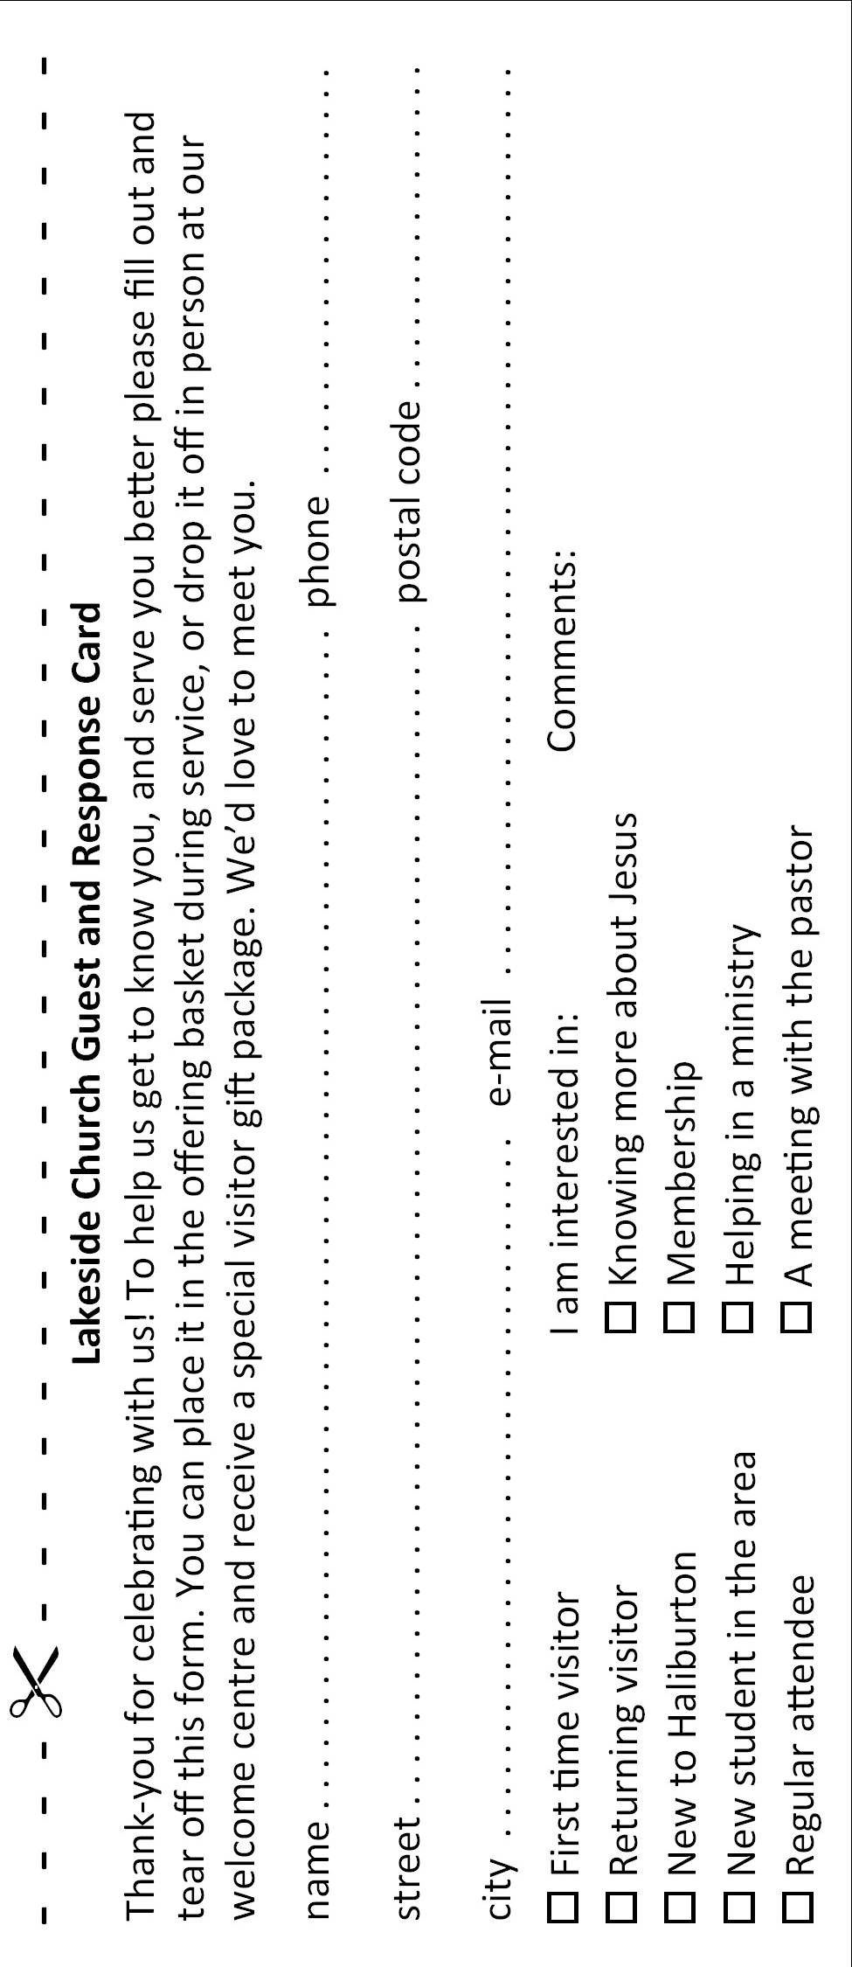
MISSIONS

Daniel and Helen Bravo – Latin American Mission Canada (www.lamcanada.ca) Baranquilla, Columbia. The border between Venezuela and Columbia has been closed. This impacts on a number of plans. Daniel’s trip to Maracaibo, Venezuela this fall is on hold. Also the usual sending and receiving of resources, supplies and volunteers across the border has become very difficult. Please pray for God’s intervention and the reopening of the border to allow ministry to both Columbians and Venezuelans to continue.

PROGRAMS

Men and Women - Join us for a no-homework study ‘Jesus, Experiencing His Touch’ Tuesday evening at 7:00 pm to 8:30 pm. See study description and details in the lobby.

PROGRAMS (Cont’d)

Youth Grades 9-12 – Bible study Tuesday evenings at 7:00 pm at Lakeside and will run for 8 weeks. Girls and guys will be separately studying ‘Authentic Love’ by D A Horton and Amy-Jo Girardier. Please call or text Micheon Hutchings at 705-457-7412.

Men’s Study – Come and join us for a 4-week study by Tony Evans called ‘Watch Your Mouth’. This study will teach us about the power of our tongues for both good and evil. This group runs every second Tuesday (next meeting October 31st). It is held at the rec room from 7:30 – 9:00 pm. For more information, email: men@mylakeside.ca.

Women of the Word (WOW) Lakeside women and friends come
and join us Wednesday morning at 9:15-11:45 am to have a time of bible study (three options to choose from) and a time to visit with your sisters in Christ. For more information, contact Wendy in the office or email wendy@mylakeside.ca/ Childcare is provided.

SHEPHERD’S TABLE

Our next dinner will be held on Friday, December 15th at 5:30 pm. Come and invite a friend to enjoy a turkey dinner. Please contact Wendy in the Church office if you are able to help with the meal preparation on Thursday and/or Friday as well as serving our guests.

GUESS WHO’S COMING TO DINNER

Guess Who’s Coming to Dinner – November 18th at 6:00 pm. Do you like great food, fun and getting to know people? Then this event is for you! Sign up as a guest and you will be directed to a surprise host’s home or sign up as a host and you will have surprise guests come to dinner. You set the menu and number of guests. Sign up forms are at the kiosk.

PREGNANCY CARE CENTRE

Something Just for Dads – This is a time for dads or men who are filling a fathering role to meet together with other dads to talk, share and ask questions. Thursday, November 2nd and Thursday, December 7th at 6:30 pm. We will meet at the Pregnancy Care & Family Support Centre, 187 Highland St. Haliburton. For more information, please call 705-457-4673.

